How to setup bridge for one button for O6
Model Number: O6V1.0 Question Classification: Function Settings
Part 1：Prepare for configuration
Part 2：Detailed operation
Part 3: Remote debugging and installation of equipment
- The two O6 (B A/ device), two cables, two power supply.
- Use the power supply, network cable, respectively, to equipment A, equipment B electrify:
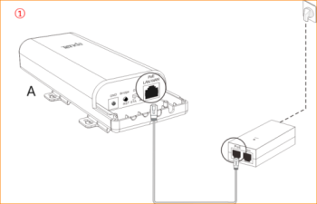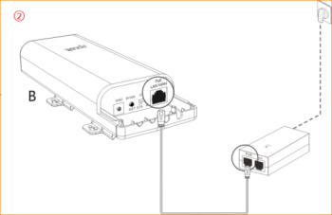
After the equipment A is energized with the equipment B, the positions are placed together in a relative distance of about 10 meters
- The equipment of A mode switch to AP position, as figure ③;Press Bridge/RST button of equipment A for 3~7 seconds and then release , as figure ④; the signal strength indicator (LED1, LED2, LED3) began to flicker, as figure ⑤:
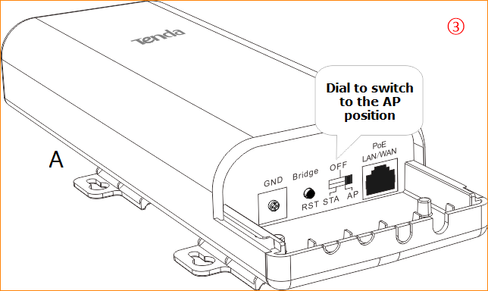
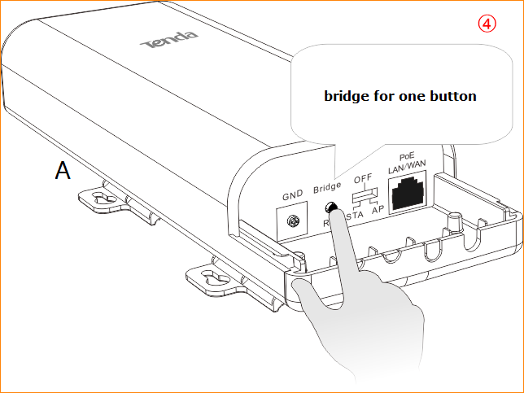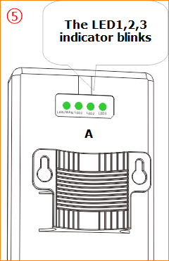
- Within the 2 minutes, the equipment of B mode switch to STA position, as figure ⑥;Press Bridge/RST button of equipment A for 3~7 seconds and then release , as figure ⑦; the signal strength indicator (LED1, LED2, LED3) began to flicker, as figure ⑧:
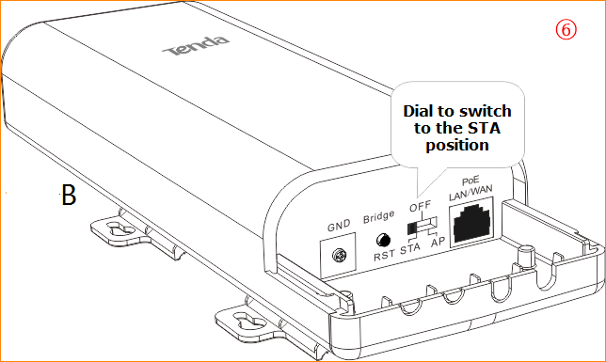
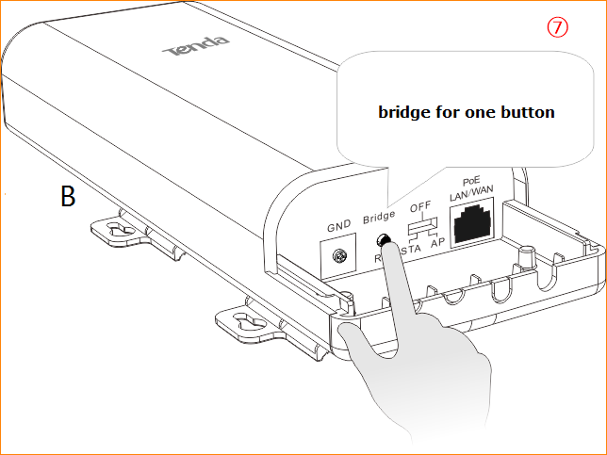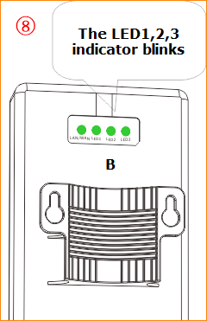
Note: during the negotiation of the two devices, the signal intensity indicator (LED1, LED2, LED3) of the equipment is extinguished first, then always bright, and often bright, indicating the bridge is successful, as figure ⑨:
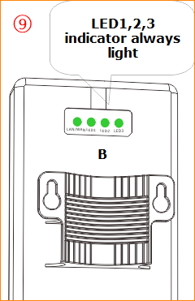
After the success of the bridge, equipment A and B installed on the pole at the corresponding position, which relative to the height
- By viewing the signal strength indicator (LED1, LED2, LED3) micro adjust the height and direction of the two devices, signal strength indicator lamps are lit for the best position.
- The LED1, LED2, LED3 respectively different signal strength threshold, LED1 defaults to -90dBm LED2 defaults to -80dBm LED3 default to -70dBm. can be modified in the Web equipment management page by default:
- if the -90dBm< wireless signal strength on the side of the <-80dBm, LED1 light.
- if the -80dBm< wireless signal strength on the side of the <-70dBm, LED1, LED2 light.
- if the -70dBm< on the side of the wireless signal strength, LED1, LED2, LED3 light.
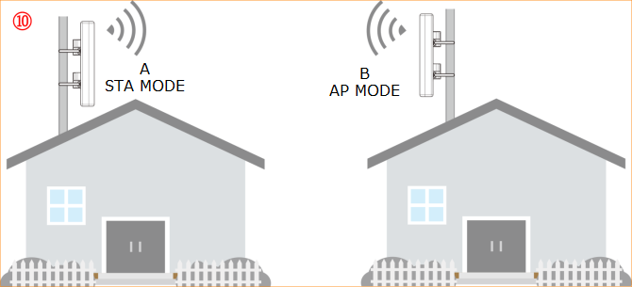
The switch which connected camera link to LAN port of equipment AP of the power supply terminal, the switch which connected NVR link to LAN port of equipment STA of the power supply terminal.
